Jack McCombs
Mrs. Rutan
Creative Writing
28 March 2017
Care Guide for Mabel
Jack McCombs
Absorb the information about my canine best friend. Everything listed below is a complete guide to taking care of my dog, Mabel. You will find this of great value, if you find yourself her caregiver, or someone who wants to know about her.

Exterior: You should probably know that the shiny bald man we bought her from said she was “A pure Lab.” With one look you can tell that man is a liar. Mabel sports a light and dark brown coat, creating subtle, yet definitive stripes and contrast. She is equipped with a rather narrow face. Her navel makes a concave figure with her hind legs and chest, and she has a freckle on her nose; she’s an owner of some crooked bottom teeth as well. My family and I spent about two years trying to figure out what she is mixed with. That case went cold. We weren’t getting anywhere, nor did my family and I even care so we threw in the towel. So when someone asks, simply reply with, “Lab mixed with something.”

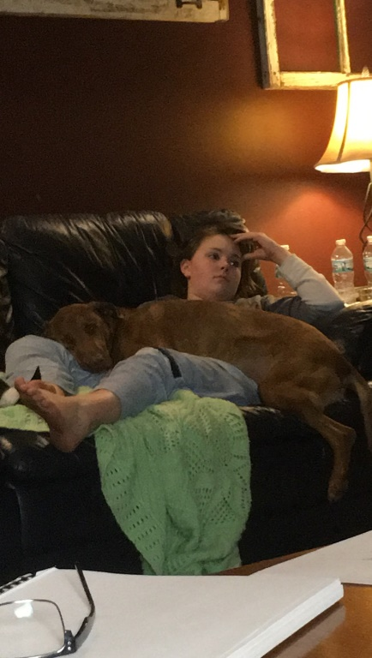
Uneasiness: You should probably know that Mabel has a strong fear of--well--everything. A few examples include lighters, power drills, air compressors, vacuum cleaners, lawn mowers, aerosol cans, spray bottles, cups of water, water, bodies of water, hoses of any kind, trimming her nails, speaking loudly, blowing air in her face. From this you can infer one thing for certain, Mabel has never had a bath… As my dad says, “The damn dog that has never had a bath, no wonder she stinks.” No one else thinks she stinks though. Mabel is also scared of Ruby. The younger chihuahua, Ruby, rules Mabel like a slave. Food is dropped on the floor, Ruby will go after it and Mabel won’t even move, she will paint a sad look on her face. Mabel has a bone, Ruby will hijack it from her like a bandit and prance off to the other room. All in all, Mabel can be ruled by the gross, four pound rat.

Activities: Fetch? Mabel does not know this game. She only knows “Chase,” which is reverse fetch. Throw her a toy, stick, or piece of trash, and she will bound after it at high rates of speed, scoop whatever object was catapulted, and tear back in the direction in which you stand. The moment you believe she might actually bring it back for once, she will flaunt her speed and will blow right by you. It’s okay to feel discouraged when she turns around and flies by you like a bat out of hell, again and again and again. You will not catch her outdoors. Indoor “Chase” is a different game, You have the ability to set up barriers. Handcrafted from pillows, chairs, or a baby gate, then trap her and seize whatever object she has. Play this game with her as much as possible and she will love you forever. When you get home--one hundred percent of the time--she will bring you the first shoe she sniffs out, regardless the owner. This is because she want you to chase her around--like an idiot. If you do not succeed, she will just drop the shoe off wherever it is most convenient for her. Good luck finding your other shoe.
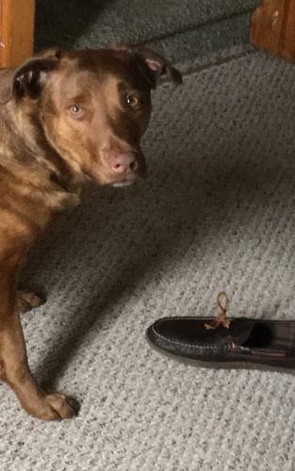
“Tricks”: “Sit. Shake. Lay down. Lay-down!” It will become obvious that Mabel decides to submit herself to commands, but only with the variable of a toy, or food, minus celery. You can use these “tricks” if you want some stunningly dull entertainment. Getting her to lay down can be a tough one. She is so reluctant to do it, I often wonder if it hurts her feelings or something because you have to say it around five thousand times. She’ll shake without you asking her though.

Pet Peeves: Perhaps this is my favorite topic. It is fun to break down these specific annoyances and put them up in the air for you. So read carefully, but take these with a grain of salt. First off, I cannot fathom why Mabel will take things outside, usually someone's shoe, one of her own toys, an empty water bottle, but can never bring it back inside. Even if it is her favorite toy, she will NEVER bring it back indoors. Secondly, if you’re just watching TV, she will conjure water bottle and chew on it, like it tastes good. This particular sound drowns out the TV and leaves your ears full of the obnoxious water-bottle-chewed-by-Mabel-sound…

The End: You will probably love Mabel. She is easy to please, and easy take care of. She is hilarious and will make you laugh frequently. I hope you enjoy taking care of her. She will take to you just fine, because she is the most loving dog I’ve ever known.

